**World Veterinary Day Saturday 28 April 2018**

**in Tanzania**

 **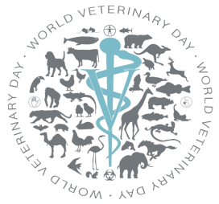 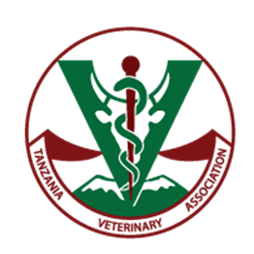 logo_new**

**To celebrate the World Veterinary Day (WVD) in Tanzania that will take place globally on 28th April 2018, the World Veterinary Association (WVA), The Ministry of Livestock and Fisheries, The Tanzania Veterinary Association and the Veterinary Council of Tanzania are organising the World Veterinary Day in Tanzania.**

|  |
| --- |
| **THE THEME 2018**  **THE ROLE OF THE VETERINARY PROFESSION IN SUSTAINABLE DEVELOPMENT TO IMPROVE LIVELIHOODS, FOOD SECURITY AND SAFETY** |

A large part of the Tanzania population lives in rural areas where animals are indispensable for their livelihood and access to food. **4.6 million** households which is **50%** of all households in Tanzania keeps livestock, of which **53%** keep poultry, **35%** keep cattle, **10%** keepgoats, **4%** keep pigs and **1%** keep sheep . For numerous households, animals are also the best means to preserve the necessary resources to cope with agricultural crises, to exit poverty, or to help to keep the soil fertile and provide traction for ploughing and transport.   
  
It is estimated that the world population will reach **9.7 billion** people by 2050 and in Tanzania the population may reach 100 **million** people and the demand for animal protein and by-products will grow respectively. By preventing and controlling animal diseases, veterinarians play a crucial role in securing sufficient and safe high-quality food, improving the health and welfare of people and animals. They contribute to ensure the existence of sufficient resources for future generations by supporting the development of sustainable, responsible and efficient livestock production systems.  
   
Furthermore, the veterinary profession is responsible for the control and inspection of animal products at all stages “from farm to fork” to guarantee safe food to the world population. It also positively impacts a wide range of employment fields that deliver services for the benefit of society and all animals.

*JOIN THE VETERINARY PROFESSION IN THEIR ENDEAVOUR TO GUARANTEE THE WORLD AND TANZANIA IN PARTICULAR WITH SAFE FOOD FROM ANIMALS*